Test Case: runTestMultipleTimes
Step 1 - Enter username and password and click to button Enter : Credentials Entered
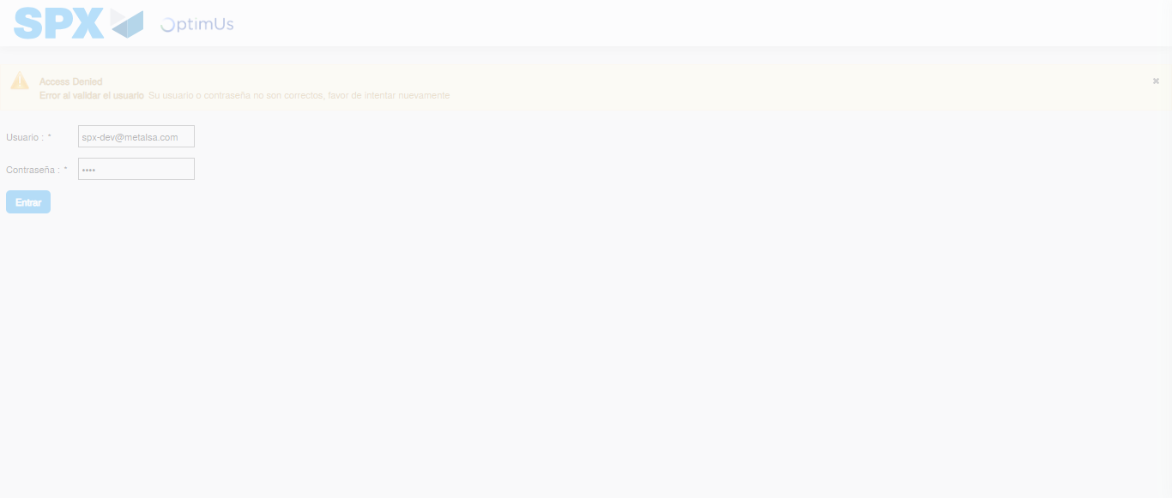Image file-name: QC_Testing-runTestMultipleTimes-dic. 03 2025, 09 28 03 a. m.

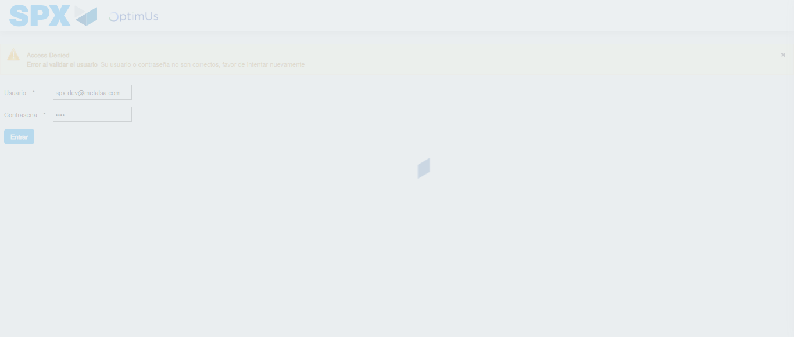Image file-name: QC_Testing-runTestMultipleTimes-dic. 03 2025, 09 28 04 a. m.

Step 2 - Select to UEN and Access to Administrador Roles Menu: UEN Correctly selected and Correct access
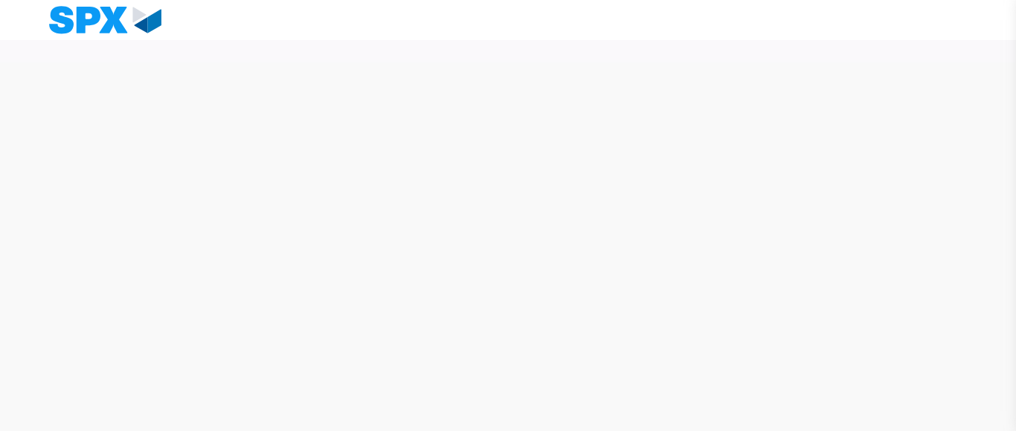Image file-name: QC_Testing-runTestMultipleTimes-dic. 03 2025, 09 28 07 a. m.

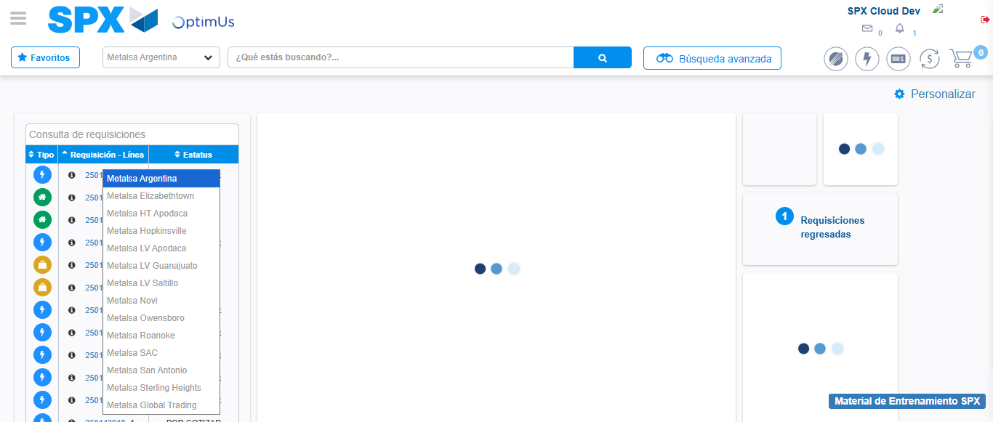Image file-name: QC_Testing-runTestMultipleTimes-dic. 03 2025, 09 28 12 a. m.

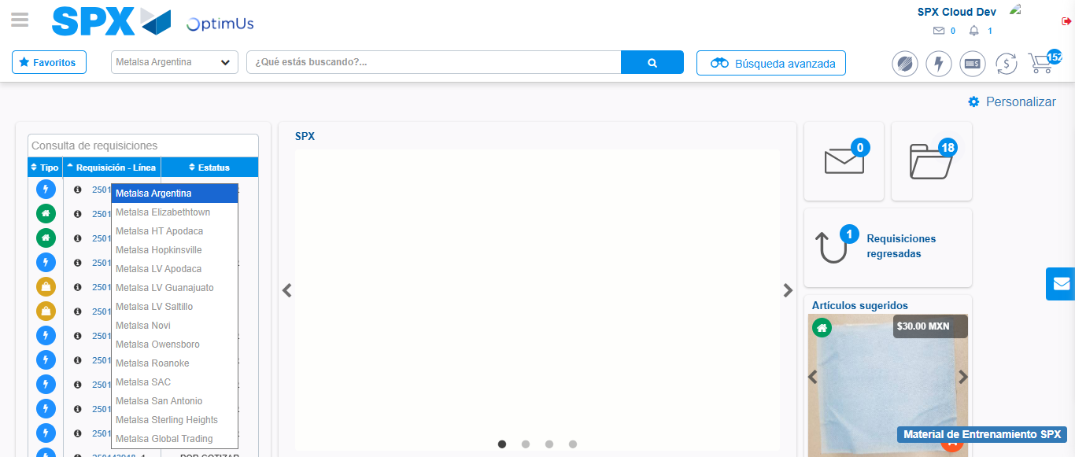Image file-name: QC_Testing-runTestMultipleTimes-dic. 03 2025, 09 28 13 a. m.

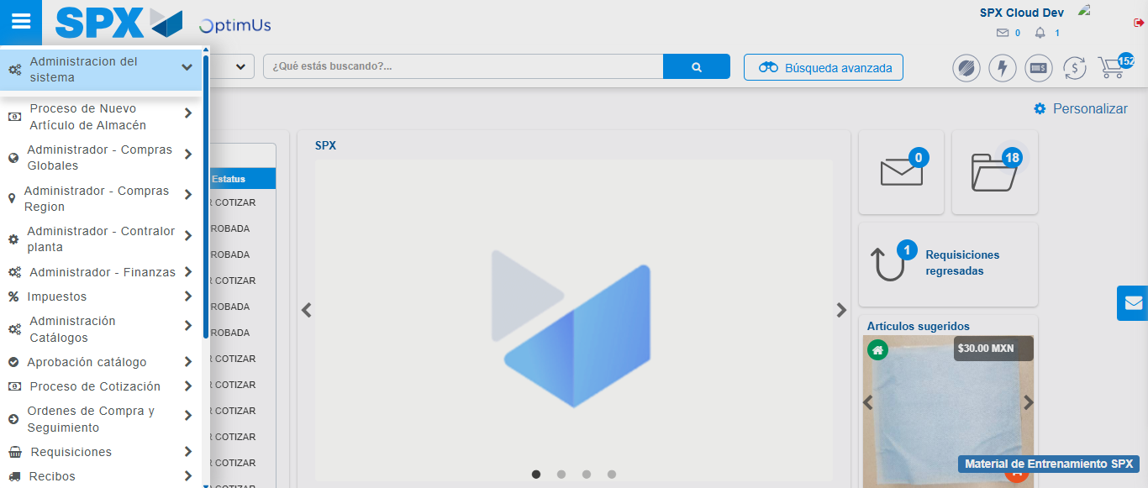Image file-name: QC_Testing-runTestMultipleTimes-dic. 03 2025, 09 28 14 a. m.

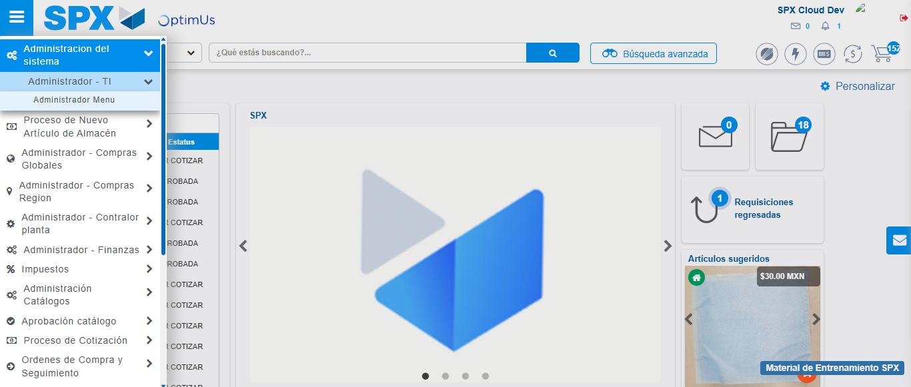Image file-name: QC_Testing-runTestMultipleTimes-dic. 03 2025, 09 28 15 a. m.

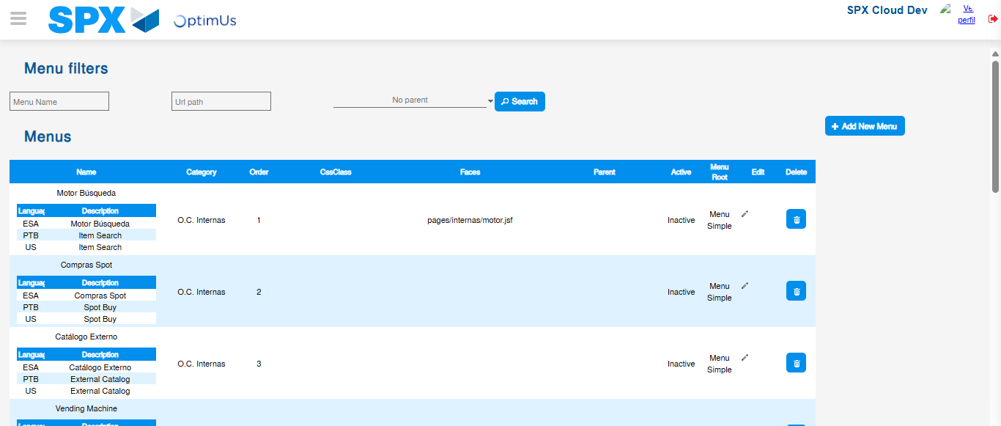Image file-name: QC_Testing-runTestMultipleTimes-dic. 03 2025, 09 28 16 a. m.

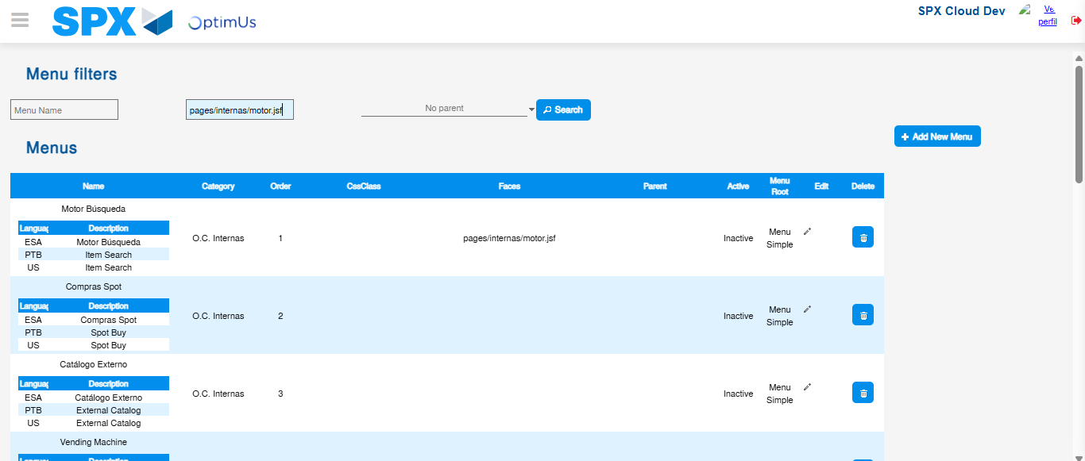Image file-name: QC_Testing-runTestMultipleTimes-dic. 03 2025, 09 28 17 a. m.

Step 3 - Perform a search with the URL Path filter: Successful search
Image file-name: QC_Testing-runTestMultipleTimes-dic. 03 2025, 09 28 17 a. m.

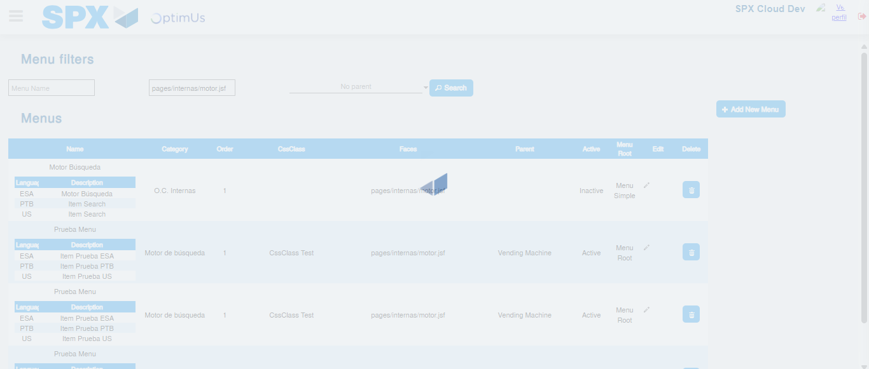Image file-name: QC_Testing-runTestMultipleTimes-dic. 03 2025, 09 28 18 a. m.

